Technical and Economical Evaluation of Concentration, Oxidation and Gold Extraction from Sulfide Ore of Chah-Zard

Supplementary Information
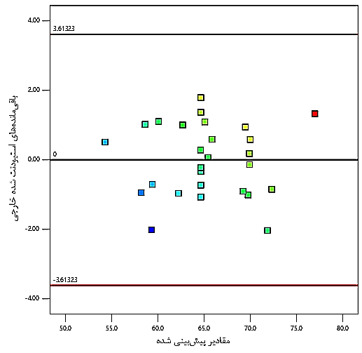
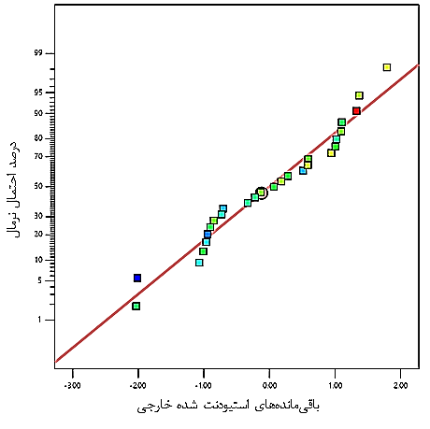
- normal residuals plot.
B- plot of residuals versus predicted values.
Predicted Values
Externally Studentized Residuals
Percent Normal Probability
Externally Studentized Residuals

Fig. S1. Charts of Gold Recovery Model Validation

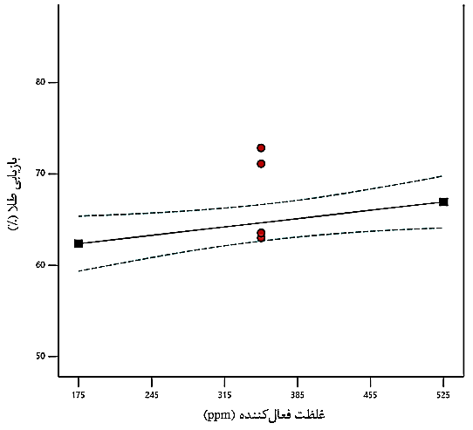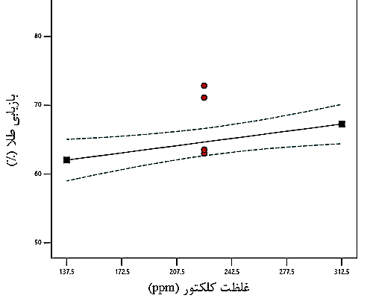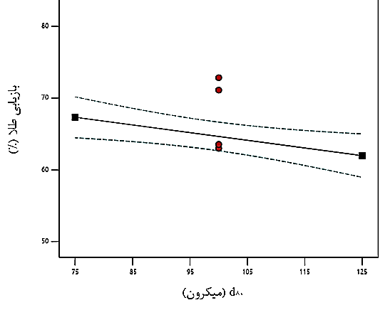
Collector Concentration (ppm)
D₈₀ (Micron)
Gold Recovery (%)
Gold Recovery (%)
Gold Recovery (%)
Activator Concentration (ppm)
- Plot of gold recovery changes versus collector concentration.
B- Plot of gold recovery changes versus activator concentration.
C- Plot of gold recovery changes versus particle size distribution.
Fig. S2. Variations in gold recovery relative to collector concentration, activator concentration, and particle size.

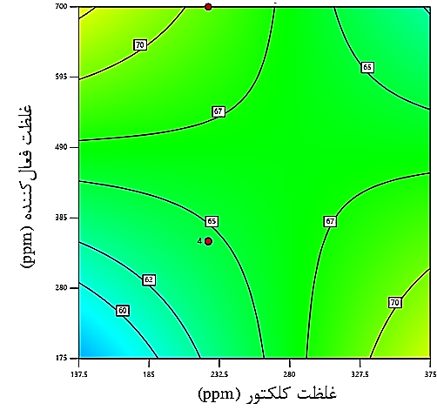
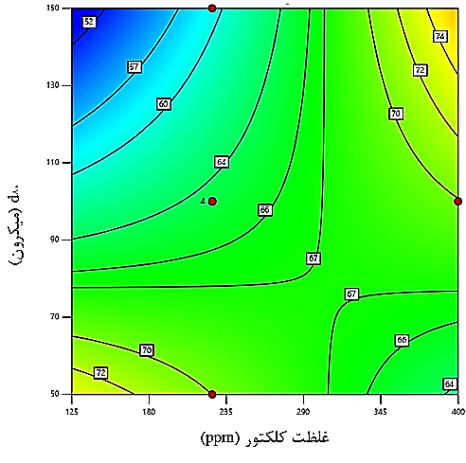
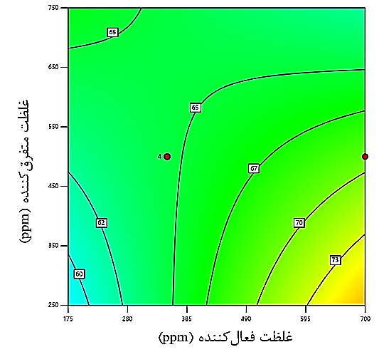
A. Gold recovery contour against collector concentration and particle size distribution.
B. Gold recovery contour against collector concentration and activator concentration.
C. Gold recovery contour against activator concentration and dispersant concentration.
Activator Concentration (ppm)
Dispersant Concentration (ppm)
Collector Concentration (ppm)
Collector Concentration (ppm)
Activator Concentration (ppm)
D₈₀ (Micron)
Fig. S3. Contour related to the interactive effect of dual factors on gold recovery in the concentrate.

Table S1 - XRD Analysis Results.
Main Phases | Formula | Mineral Name | Minor Phases | Formula | Mineral Name | Very Minor Phases | Formula | Mineral Name
Quartz | SiO2 | Quartz | Gypsum | CaSO4·2H2O | Gypsum | Chlorite | (Mg,Fe)6(Si,Al)4O10(OH)8 | Chlorite
Albite | NaAlSi3O8 | Albite | Pyrite | FeS2 | Pyrite | - | - | -
Muscovite | KAl2Si3AlO10(OH)2 | Muscovite | - | - | - | - | - | -
Potassium Feldspar | KAlSi3O8 | Potassium Feldspar | - | - | - | - | - | -

Table S2 - XRF Analysis Results.
Main Oxides | SiO₂ | Al₂O₃ | BaO | CaO | Fe₂O₃ | K₂O | MgO | MnO | Na₂O | P₂O₅ | SO₃ | TiO₂ | LOI
Content (%) | 60.93 | 14.58 | 0.12 | 1.62 | 3.97 | 6.49 | 0.99 | 0.36 | 1.03 | 0.13 | 0.4 | 0.4 | 4.26

Table S3 - ICP-MS Analysis Results.
Element | Al | As | Ba | Be | Bi | Ca | Cd | Ce | Co | Cr | Cs | Cu
Grade (g/t) | 1951 | 1010 | 514 | 0.16 | <0.1 | 830.8 | 0.55 | 9 | 9 | 76 | 9.7 | 33
Element | Dy | Er | Eu | Fe | Gd | Hf | In | K | La | Li | Lu | Mg
Grade (g/t) | 1.4 | 1.7 | 1.8 | 7047 | 2.73 | 0.15 | <0.1 | 38891 | 11 | 30 | <0.1 | 4128
Element | Mn | Mo | Na | Nd | Ni | P | Pb | Pr | Rb | S | Sb | Sc
Grade (g/t) | 1848 | 19 | 85331 | 41.8 | 48.1 | 55 | 0.2 | 6.78 | 14802 | 15.7 | <0.1 | 5.16
Element | Se | Si | Sr | Ta | Tb | Te | Th | Ti | Tl | Tm | U | V
Grade (g/t) | <0.1 | - | 134 | 0.14 | <0.1 | 0.14 | 6 | 1810 | 7.7 | <0.1 | 4.5 | 26
Element | W | Y | Yb | Zn | Zr | - | - | - | - | - | - | -
Grade (g/t) | 45 | 19.3 | - | 26 | - | - | - | - | - | - | - | -

Table S4 - ANOVA for Weight Recovery Response of Concentrate.
Source | Sum of Squares | Degrees of liberation | Mean Squares | F-value | p-value | Significance
Model | 238.45 | 3 | 79.48 | 14.93 | 0.0027 | Significant
B | 61.54 | 1 | 61.54 | 11.56 | 0.0366
÷ | 49.72 | 1 | 49.72 | 9.34 | 0.0139
D | 117.4 | 1 | 117.4 | 22.05 | 0.0033
Residual | 101.17 | 19 | 5.32 | - | -
Lack of Fit | 45.71 | 16 | 2.86 | 0.1546 | 0.8464 | Not Significant

